**CMOS Imaging Sensor Circuit Board Assembly Information**

* Top layer component descriptors: Mechanical layer 5
* Bottom layer component descriptors: Mechanical layer 6
* Double sided assembly: Yes
* 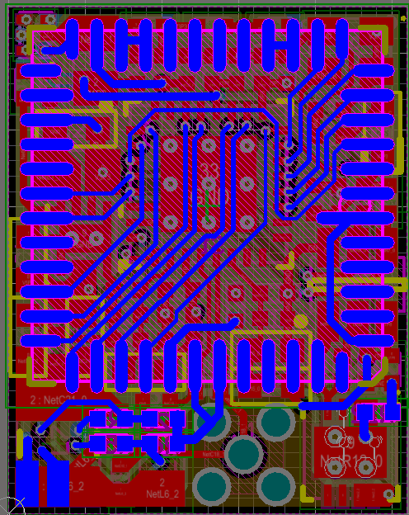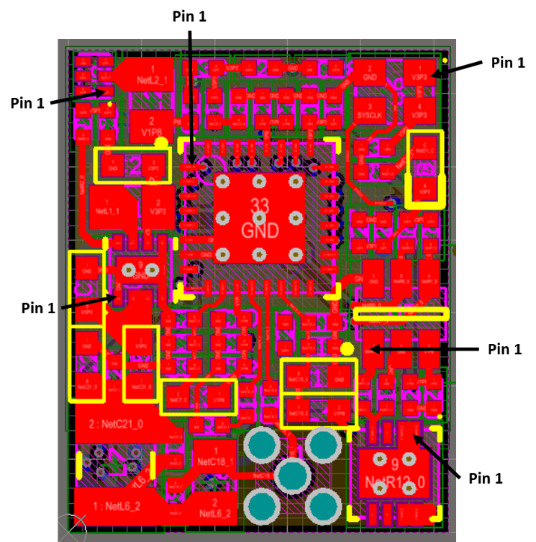Pin 1 identifiers shown below

Pin 1 of S1

* D1 (LED) orientation shown below

